7. Project Documentation

Project documentation is the process of recording all important information related to the development and implementation of the project. Documentation provides a permanent reference that explains the purpose, requirements, design, development process, testing results, and final outcome of the system. It is useful for project evaluation as well as future maintenance and improvement. A properly prepared document allows another person to understand the project even without directly communicating with the original development team. Therefore, documentation should be maintained throughout the project rather than being prepared only at the end.

The introduction section of the documentation explains the background and motivation of the project. It describes the problem being addressed and explains why an AI, ML, or Generative AI based solution is considered appropriate. The project objectives and expected outcomes are also clearly stated. This section provides readers with a basic understanding of the purpose of the application. A clear introduction makes it easier to understand the technical sections that follow.

The requirement analysis and system design are documented in detail. Functional and nonfunctional requirements, hardware requirements, software requirements, and data requirements are included. Architecture diagrams, flowcharts, database designs, use-case diagrams, and other relevant diagrams can be added to explain the system structure. These visual representations make complex technical concepts easier to understand. The documentation should explain how different modules communicate and how the complete workflow operates.

The implementation section describes the technologies, programming languages, libraries, frameworks, databases, and AI or ML models used in the project. Important implementation decisions are explained along with the reasons for selecting particular approaches. The data preprocessing steps, model training process, application development, and integration procedures can also be documented. Code snippets may be included where necessary, while the complete source code can be maintained in a version-controlled repository. This section provides technical information useful for future developers.

The machine learning or Generative AI component should receive appropriate documentation because it is a major part of the project. The dataset source, preprocessing methods, model architecture or model selection, training procedure, parameters, and evaluation metrics can be recorded. For Generative AI applications, prompt design, model configuration, input processing, and output handling may also be documented. Limitations of the model should be mentioned clearly. Such documentation improves transparency and makes future experimentation easier.

Testing results are also included in the project documentation. The document can contain test cases, expected results, actual results, identified errors, corrective actions, and final outcomes. Model evaluation metrics and performance observations can be presented using tables or graphs where appropriate. Screenshots of important application screens may also be included to demonstrate the working system. Properly recorded testing evidence shows how the team verified the project against its requirements.

User documentation can be prepared to explain how the final application should be operated. Installation instructions, system requirements, login procedures, input instructions, output interpretation, and common troubleshooting steps can be provided depending on the project. Simple language should be used so that users without technical knowledge can understand the instructions. Developer documentation can separately explain the internal architecture and maintenance procedures. Maintaining both types of documentation improves the long-term usability of the project.
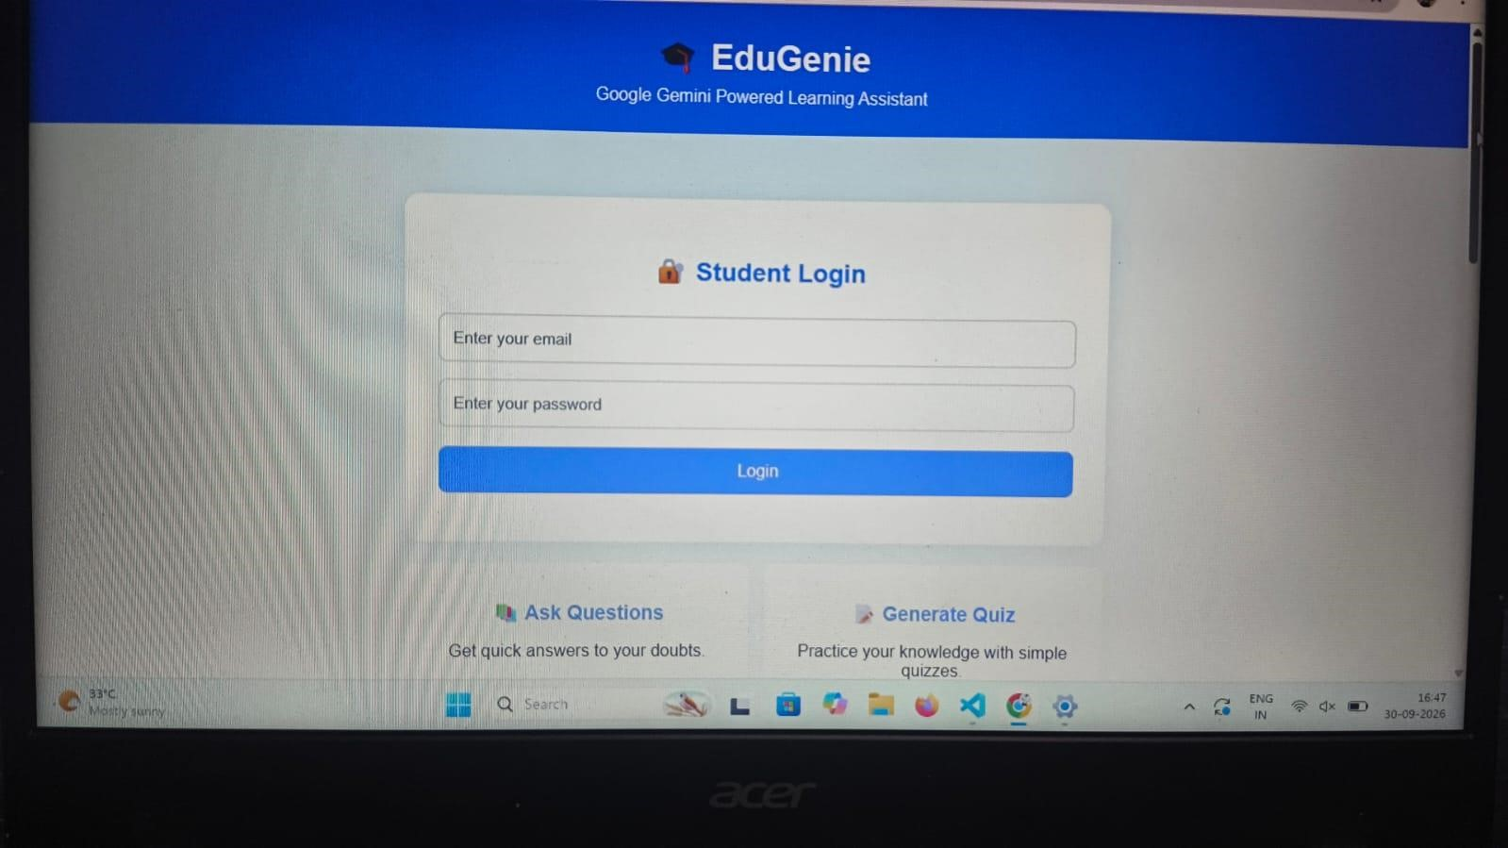
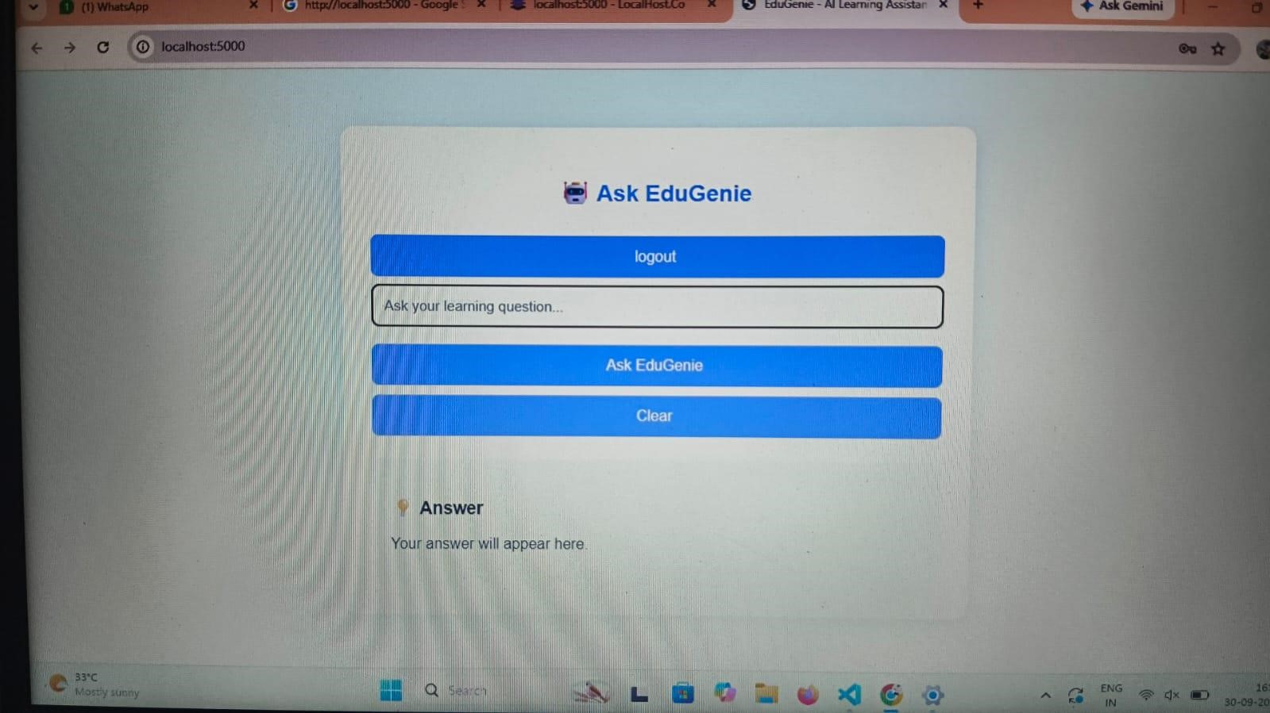
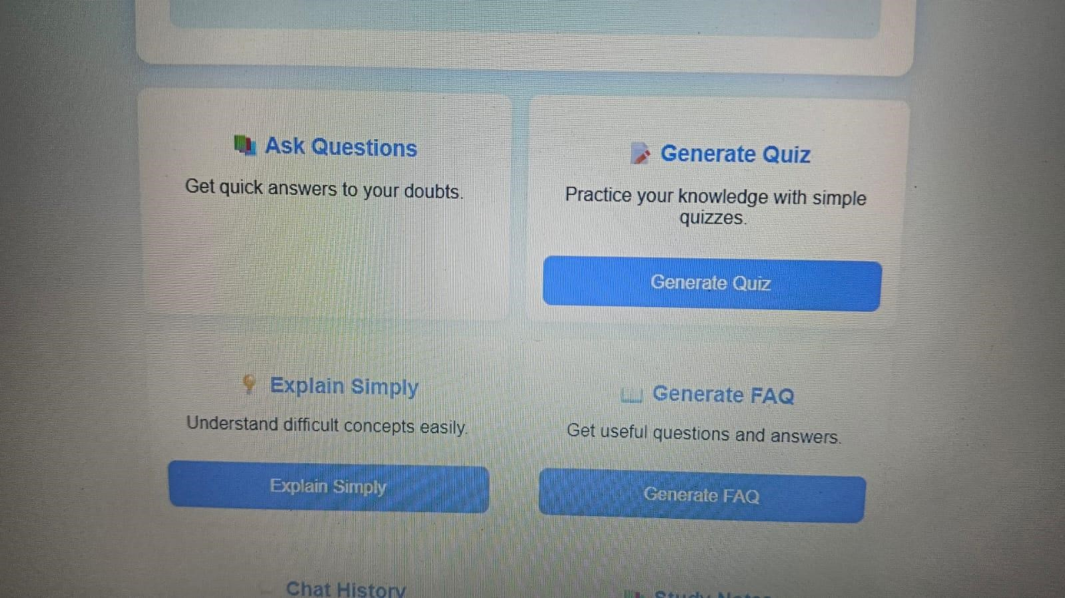
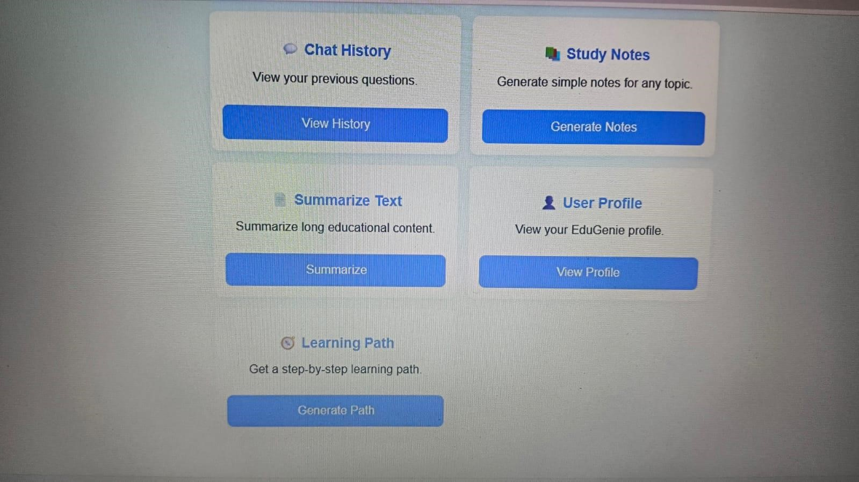
In conclusion, project documentation provides a complete record of the project's journey from initial idea to final implementation. It captures the problem statement, requirements, design, development, testing, results, limitations, and future scope in a structured manner. Good documentation supports project evaluation and makes future maintenance or expansion easier. It also demonstrates the team's understanding of the technologies methodologies used. Therefore, documentation is an essential part of the project and should be treated as an important deliverable rather than merely a formal requirement.

